**INSTITUTE OF AERONAUTICAL ENGINEERING**

**DUNDIGAL , HYDERABAD**

****

**TWO WEEKS SUMMER INTERNSHIP**

**ON**

**KIDNEY STONE PREDICTION SYSTEM USING MACHINE**

**LEARNING**

**BY**

**SALLANGULA USHA**

**21955A0423**

**ELECTRONICS AND COMMUNICATION ENGINEERING**

**UNDER THE GUIDENCES**

**OF**

**DR CH.V. RAMA PADMAJA**

CERTIFICATE

This is to certify that this Project Report is the bonafide work of **SALLANGULA USHA (21955A0423)**who carried out the project entitled **“KIDNEY STONE PREDICTION USING MACHINE LEARNING”** under our supervision from May 22, 2023 to June 4, 2023.

Submitted for Viva voice Examination held on -------------------------------------------

Internal Examiner External Examiner

DECLARATION

I**, SALLANGULA USHA(21955A0423),** hereby declare that the Project Report entitled “KIDNEY STONE PREDICTION USING MACHINE LEARNING done by me under the guidance of **Dr Ch. V. RAMA PADMAJA,** is submitted in fulfilment of Two Weeks Internship Program.

## DATE:

PLACE: SIGNATURE OF THECANDIDATE

ACKNOWLEDGEMENT

We are pleased to acknowledge our sincere thanks to Board of management of **IARE** for their kind encouragement in doing this project and for completing it successfully. I am grateful to them.

We convey our thanks to **Dr. G RAMU and Dr.CH V RAMA PADMAJA** for providing us the necessary support and details at the right time during the progressive reviews.

We would like to express our sincere and deep sense of gratitude to our Project Guide **Dr.CH V RAMA PADMAJA** for her valuable guidance, suggestions and constant encouragement paved way for the successful completion of my project work.

## ABSTRACT

Globally, The Incidence Of Kidney Stones(Urolithiasis) Has Increased Over Time. Without Better Treatement, Stones In The Kidneys Could Result In Blockage Of The Ureters, Repetitive Infections In The Urinary Tract, Painful Urination, And Permanent Deterioration Of The Kidneys. Hence, Detecting Kidney Stones Is Crucial To Improving An Individual’s Life. Concurrently, ML(Machine Learning) Has Gained Extensive Attension In This Area Due To Its Innate Benefits In Continuous Enhancement, Its Ability To Deal With Multi-Dimensional Data, And Its Automated Learning. Researchers Have Employed Various ML-Based Approaches To Better Predict Kidney Stones. However, There Is A Scope For Further Enhancement Regarding Accuracy. Moreover, Studies Seem To Be Lacking In This Area. This Study Proposes A Smart Toilet Model In An IOT-Fog(Internet Of Things-Fog) Environment With Suitable ML-Based Algorithms For Kidney Stone Detection From Real-Time Urinary Data To Rectify This Issue. Significant Features Are Selected Using The Posed Improved MBPSO(Improved Modified Binary Particles Swarm Optimization) To Attain Better Classification. In This Case, Sigmoid Functions Are Used For Better Prediction With Binary Values. Finally, Classification Is Performed Using The Proposed Improved Modified Xgboost(Modified Extreme Gradient Boosting) To Prognosticate Kidney Stones. In This Case, The Loss Functions Are Updated To Make The Model Learn Effectively And Classify Accordingly. The Overall Proposed System Is Assessed By Internal Comparision With DT(Decision Tree) And NB(Native Bayes), Which Reveals The Efficient Performance Of The Proposed System In Kidney Stone Prognostication.

Keywords: Kidney Stones ; Urolithiasis; Internet Of Things; Machine Learning; Particle Swarm Optimization;Extremegradientboosting

TABLE OF CONTENTS

PAGE NUMBER

ABSTRACT

CHAPTER 1 INTRODUCTION

PROJECT OBJECTIVE

MOTIVATION

PROBLEM STATMENT

KIDNEY STONE DESCRIPTION

CHAPTER 2 LITERATURE SURVEY

CHAPTER 2 RELATED WORKS/ SYSTEM DESIGN

2.1 EXISTING METHOD

2.2 PROPOSED SOLUTION

2.3 HARDWARE/SOFTWARE

CHAPTER 3 METHODOLOGY/IMPLEMENTATION

CHAPTER 4 RESULTS & DISCUSSIONS

CHAPTER 5 CONCLUSION

CHAPTER 6 REFERENCES

|  |  |  |
| --- | --- | --- |
| FIGURE NO | LIST OG FIGURES  FIGURE NAME | PAGE NO |
| 3.1 | FLOW DIAGRAM OF PROPOSED WORK | 11 |
| 3.2 | IMPLEMENTATION MODEL | 12 |
| 4.1 | USE CASE DIAGRAMS | 16 |
| 4.1.1 | UPLOAD CT SCANS | 17 |
| 4.1.2 | VIEW DETECTION RESULTS | 17 |
| 4.1.3 | MAKE PREDICTIONS | 18 |
| 4.1.4 | VIEW PREDICTIONS | 19 |
| 4.1.5 | CT SCAN SLICES | 20 |
| 4.1.6 | STONE MASKS | 21 |
| 5.4 | REGION TABLE FEATURE | 27 |
| 5.4.1 | ACCURACY GRAPH | 27 |

CHAPTER 1

INTRODUCTION

PROJECT OBJECTIVE

The objective of the project “optimizing kidney stone prediction through urinary analysis with improved binary particle swarm optimization and extreme gradient boosting” is to improve the accuracy and efficiency of predicting kidney stones using urinary analysis. The project aims to achieve this objective by combining two techniques: improve binary particle swarm optimization (IBPSO) and extreme gradient boosting (XGBoost).

MOTIVATION

The motivation of the project “optimization kidney stone prediction through urinary analysis with improved binary particle swarm optimization and extreme gradient boosting” is to address the prevalence and diagnostic challenges of kidney stones by leveraging urinary analysis and advanced the machine learning techniques. By optimizing the prediction process through improved binary particle swarm optimization and utilizing the power of extreme gradient boosting, the project aims to improve the accuracy and efficiency of kidney stone detection. The ultimate goal is to contribute to early detection, timely intervention, and better patient outcomes, reducing the burden of kidney stone on individuals and healthcare systems.

PROBLEM STATEMENT

The problem statement of the project "Optimizing Kidney Stone Prediction through Urinary Analysis with Improved Binary Particle Swarm Optimization and eXtreme Gradient Boosting" is to develop a predictive model that can accurately and efficiently predict the presence or absence of kidney stones based on urinary analysis. The project aims to address the challenge of diagnosing kidney stones, which can be difficult using conventional methods alone. By leveraging urinary analysis data and optimizing the model using Improved Binary Particle Swarm Optimization and eXtreme Gradient Boosting, the project seeks to improve the accuracy of kidney stone prediction and contribute to early detection, enabling timely interventions and potential improvements in patient outcomes.

KIDNEY STONE DESCRIPTION

Kidney stones, medically known as renal calculi, are solid deposits that form in the kidneys. These stone-like structures can vary in size, shape, and composition, and they can cause significant pain and discomfort. Kidney stones are a common urological condition, affecting people of all ages and genders. In this detailed description, we will delve into the various aspects of kidney stones, including their formation, composition, symptoms, diagnosis, treatment options, and prevention strategies.

The kidneys, part of the urinary system, play a crucial role in filtering waste products and excess fluids from the blood, producing urine. Under certain conditions, substances present in the urine can crystallize and form solid deposits. These deposits gradually grow in size, forming kidney stones. There are several types of kidney stones, each associated with specific substances:

Calcium stones: These are the most common type of kidney stones, typically composed of calcium oxalate or calcium phosphate. High levels of calcium and oxalate in the urine can lead to the formation of calcium stones.

Uric acid stones: Uric acid, a waste product resulting from the breakdown of purines, can accumulate and form uric acid stones. These stones are more likely to develop in individuals with high levels of uric acid in their urine, often associated with conditions like gout or certain metabolic disorders.

Struvite stones: Struvite stones, also known as infection stones, form in response to urinary tract infections. These stones can grow rapidly and become quite large.

Cystine stones: Cystine stones are rare and occur in individuals with a hereditary condition called cystinuria. This condition leads to the accumulation of the amino acid cystine in the urine, resulting in stone formation.

The formation of kidney stones can be influenced by various factors, including genetics, diet, hydration levels, urinary tract infections, and certain medical conditions. Dehydration, for example, can contribute to concentrated urine, increasing the likelihood of stone formation.

Symptoms of kidney stones can vary depending on their size, location, and whether they cause blockage or irritation. Small kidney stones may not cause noticeable symptoms and can pass through the urinary tract without intervention. However, larger stones can lead to severe pain, often referred to as renal colic, which is typically felt in the back or side below the ribs. The pain can radiate to the lower abdomen and groin. Other symptoms may include blood in the urine (hematuria), frequent urination, urgency, cloudy or foul-smelling urine, and discomfort or pain during urination.

CHAPTER 2

RELATED WORKS / SYSTEM DESIGN

EXISTING METHOD

The existing methods for kidney stone prediction typically involve a combination of clinical evaluation, patient history, and diagnostic tests. Here is an overview of the existing methods used for kidney stone prediction: .Clinical Evaluation and Patient History: The healthcare provider conducts a comprehensive clinical evaluation by reviewing the patient's symptoms, medical history, family history, and risk factors associated with kidney stone formation. This includes assessing factors such as age, gender, dietary habits, fluid intake, occupation, and any relevant medical conditions or medications that could contribute to stone formation.

1.Imaging Techniques: Various imaging techniques are employed to visualize the presence of kidney stones and gather information about their size, location, and number. These imaging methods may include:X-ray: X-ray images can detect most calcium-based stones, but they may not be effective for other types of stones.Ultrasound: Ultrasound imaging uses sound waves to create images of the kidneys and can help identify the presence of kidney stones, particularly larger ones. It is non-invasive and readily available.CT Scan: Computed Tomography (CT) scans provide detailed cross-sectional images and are highly effective in visualizing kidney stones of all types and sizes. CT scans can accurately determine the size, location, and number of stones.

2.Laboratory Tests: In some cases, additional laboratory tests may be performed to assess the overall kidney function and identify any underlying metabolic disorders or conditions that contribute to stone formation. These tests may include blood tests to measure levels of calcium, uric acid, and other relevant markers.

Based on the information gathered from the clinical evaluation, patient history, urine analysis, and imaging tests, healthcare professionals make predictions about the likelihood of kidney stone formation. The existing methods primarily rely on the expertise and experience of healthcare providers in interpreting the results and making predictions based on established guidelines and diagnostic criteria.

It is important to note that the existing methods are often limited to predicting the likelihood of kidney stone formation based on risk factors and diagnostic results. The accuracy of prediction may vary, and there is room for improvement in developing more advanced and precise predictive models using machine learning algorithms and optimization techniques.

2.2 PROPOSED SOLUTION

Kidney diseases, particularly kidney stones (urolithiasis), widely affect people throughout the world. Kidney stones occur due to various factors, which include diet, lifestyle, gender, socio-demographics, age, genetics, clinical features, and environmental features. Though limited studies have been conducted in the field of kidney stone prediction, an inclusive predictive model that identifies the fundamental features of kidney stones is still lacking, and there is still scope for further enhancement. The proposed method is undertaken in an IoT-fog environment that uses a real-time dataset. In the present study, the proposed method is Improved MBPSO for feature selection and Modified XGBoost algorithm for classification.The real-time dataset is considered to perform kidney stone prediction based on urine analysis.

The data are presented for pre-processing. During pre-processing, the data are checked for missing values, and categorical encoding is performed in which the data are transformed into integer format. Thereafter, the converted categorical data are given to the process of feature selection. The MBPSO method is utilized for feature selection. Thereby, the selection of the appropriate features for further process is improved and assists in the process of prediction of kidney stones. Feature selection is used to perform an accurate process by eliminating irrelevant and redundant data, increasing the prediction power. Then, 80% of the trained data and 20% of the test data are given to the classification process. The classification is performed by using a modified XGBoost algorithm, in which the algorithm is used to predict the presence of kidney stones with utmost accuracy. Additionally, the efficiency of the proposed method, which uses modified XGBoost, is evaluated based on an internal comparison with NB and DT classifiers. The standard evaluation metrics are utilized to assess the effectiveness of the proposed model.

2.2.1 PROPOSED MACHINE LEARNING ALGORITHMS

The proposed machine learning algorithms for optimizing kidney stone prediction through urinary analysis in this project are Improved Binary Particle Swarm Optimization (IBPSO) and eXtreme Gradient Boosting (XGBoost).

Improved Binary Particle Swarm Optimization (IBPSO): IBPSO is a variant of the Particle Swarm Optimization (PSO) algorithm that is specifically designed for binary optimization problems. PSO is a metaheuristic optimization algorithm inspired by the collective behavior of bird flocking or fish schooling. In the context of this project, IBPSO can be utilized to optimize the selection of relevant features from urinary analysis data, identifying the most informative features for kidney stone prediction. By effectively selecting features, IBPSO can help enhance the performance and efficiency of the prediction model.

eXtreme Gradient Boosting (XGBoost): XGBoost is a powerful and widely used machine learning algorithm that belongs to the gradient boosting family. It combines the principles of gradient boosting with a highly optimized implementation, making it highly efficient and effective for various prediction tasks. XGBoost is known for its ability to handle complex, high-dimensional datasets and provide accurate predictions. In this project, XGBoost can be applied to develop a predictive model using the selected features from urinary analysis. The algorithm learns from the data and builds an ensemble of weak learners (decision trees) to make accurate predictions about the presence or absence of kidney stones.

By combining IBPSO for feature selection and XGBoost for prediction modeling, the proposed approach aims to optimize kidney stone prediction through urinary analysis. The synergy between these algorithms can potentially improve the accuracy and efficiency of the prediction model, enabling early detection and timely intervention for kidney stone management.

2.2.2 FLOW DIAGRAM

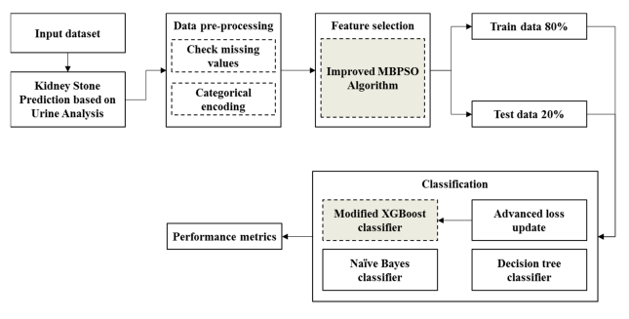

2.3 HARDWARE / SOFTWARE

2.3.1 HARDWARE REQUIREMENTS

Laptop (Core i3)

RAM 4GB

2.3.2 SOFTWARE REQUIREMENTS

Python

Machine Learning Libraries

Data Analysis and Visualization Libraries

Google Collab

CHAPTER 3

METHODLOGY/ IMPLEMENTATION

The methodology and implementation process for optimizing kidney stone prediction through urinary analysis with Improved Binary Particle Swarm Optimization (IBPSO) and eXtreme Gradient Boosting (XGBoost) typically involve the following steps:

STEP 1: Input the kidney stone prediction dataset

STEP 2: Data Collection: Gather a comprehensive dataset of urinary analysis data from individuals with known kidney stone outcomes. This dataset should include relevant features such as pH levels, mineral concentrations, crystal formation, and other factors that may contribute to stone formation.

STEP 3: Data Preprocessing: Clean and preprocess the collected dataset to handle missing values, outliers, and ensure data consistency. Perform feature engineering techniques to extract useful information from the raw data, and split the dataset into training and testing sets.

STEP 4: Feature Selection with IBPSO: Apply IBPSO algorithm to optimize feature selection from the urinary analysis dataset. IBPSO will iteratively search for the most informative subset of features that maximize the predictive performance. Evaluate the fitness of each feature subset based on a predefined evaluation metric (e.g., accuracy, area under the ROC curve) using XGBoost as the base classifier.

STEP 5: Model Training with XGBoost: Utilize the selected features to train an XGBoost model. XGBoost is a gradient boosting algorithm that sequentially builds an ensemble of decision trees to make predictions. Tune the hyperparameters of XGBoost using techniques like grid search or random search to optimize its performance.

STEP 6: Model Evaluation: Evaluate the trained XGBoost model using the testing dataset. Assess its performance metrics such as accuracy, precision, recall, and F1-score to measure the effectiveness of the prediction model. Use appropriate evaluation techniques such as cross-validation to ensure robustness and generalizability of the model.

STEP 7: Optimization and Refinement: Iterate and refine the model by fine-tuning the hyperparameters, re-evaluating feature subsets with IBPSO if necessary, and optimizing the overall performance.

STEP 8: Validation and Comparison: Validate the optimized model on an independent dataset or perform a comparative analysis with existing methods or models to assess its superiority in terms of prediction accuracy and efficiency.

STEP 9: Deployment and Monitoring: Once the optimized model demonstrates satisfactory performance, deploy it for kidney stone prediction applications. Monitor the model's performance over time and update it as new data becomes available or when improvements are warranted.

Throughout the implementation process, it is essential to adhere to standard machine learning best practices, including proper data handling, model validation, and ethical considerations for handling sensitive medical data. Collaboration with domain experts, such as urologists or nephrologists, can provide valuable insights and ensure the clinical relevance of the developed prediction model.

CHAPTER 4

RESULTS & DISCUSSIONS

The results that have been attained by implementing the proposed system for the prediction of kidney stones are included in this section with dataset description, performance metrics, exploratory data analysis, implementation results, performance analysis, and internal results.

4.1. Dataset Description:

The initial phase is to collect real-time data using the sensors to predict the existence of kidney stones (urolithiasis) based on urine analysis. IoT-based data collection is performed for the assessment or prediction of urolithiasis. Six characteristics of urine, including the pH of urine (pH), the osmolality of urine (osmo), the conductivity of urine (cond), the specific gravity of urine (gravity), the concentration of calcium in the urine (calc) and the concentration of urea in urine (urea), are considered. The values collected from both healthy persons and patients by using the system are used for the prediction of kidney stones.

4.2. Performance Metrics

4.2.1. Accuracy

The term accuracy can be referred to as the model classification rate that is provided through the proportion of correctly classified instances (TruPositive + TruNegative) to the sum Mathematics 2023, 11, 1717 12 of 22 of instances in the dataset (TruPositive + FalPositive+TruNegative + FalNegative). The following Equation (8) can be used to calculate the accuracy range: Accuracy = TruNegative + TruPositiveTruNegative + TruPositive + FalNegative + FalPositive.

4.3. Exploratory Data Analysis

EDA denotes the necessary procedure of performing primary investigations on the data to realize patterns, experiment hypotheses, verify assumptions, and denote data characteristics with the help of graphical representations and summary statistics. This section discusses the exploratory data analysis of the proposed model in the present study by using an SNS plot, as shown in Figure 3. In the SNS plot, the significant features of the figure-level functions are specified and easily created by using multiple sub-plots. Selected features including (calc, gravity, Osmo, pH, cond, urea, and target) are represented in detail by using the SNS plot, as shown in Figure 1. The correlation coefficients of the selected variables (calc, gravity, Osmo, pH, cond, urea and target) are shown in the correlation matrix. The correlations among the possible pairs are depicted in the matrix shown in Figure 2. A box plot depicts a set of numerical data and provides a visual form of the data. By using a box plot, the attributes can be compared easily. It provides a graphical summary of the attributes, and the average value of the data is easily identified in the box plot of the selected data, as shown in Figure 3.

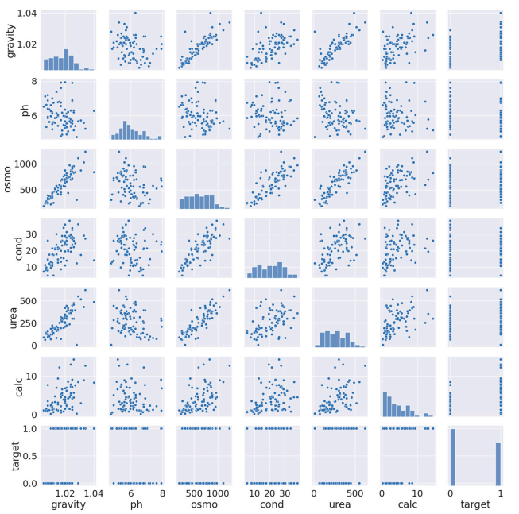

Figure 1 : SNS plot

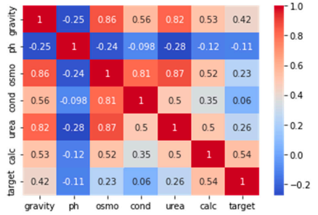

Figure 2 : Correlation matrix

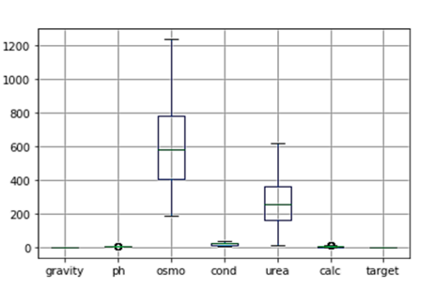

Figure 3 : Box plot

Target 0 represents the absence of kidney stones and target 1 represents the presence of kidney stones, which have been found by using the collected dataset and by analyzing the features of the data. The histogram that represents the presence and absence of kidney stones is shown in Figure 4.

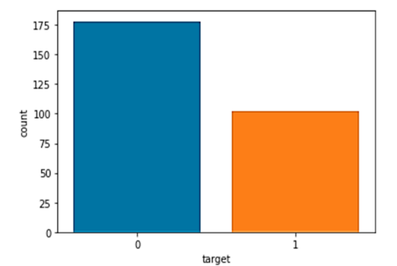

Figure 4: Histogram representing the targeted values.

4.5. Performance Analysis

The performance of the proposed system is assessed based on the ROC curve and confusion matrix. The corresponding outcomes are discussed in this section. The data features, which include calc, gravity, Osmo, pH, cond, urea, and their relative importance, are shown in Figure 8. From Figure 8, it is observed that the calc feature has more importance in comparison with other feat.

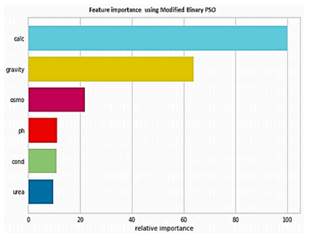

Figure 5: Feature Feature importance of MBPSO.

Figure 6. Confusion matrix of the modified xgboost. Figure 7. Confusion matrix of dt. Feature selection of mbpso. Figure 10 shows the confusion matrix of the modified xgboost classifier, which illustrates the prediction of kidney stones. By using the modified xgboost classifier, the correct predictions are given as 53—the absence of kidney stones and 28—the presence of kidney stones. However, three classifications have been misinterpreted as having no kidney stones, but the modified xgboost classifier predicts wrongly. Additionally, figure 7 shows the confusion matrix of the dt classifier, which illustrates the prediction of kidney stones. Using the dt classifier, the correct predictions are 53—the absence of kidney stones and 18—the presence of kidney stones. However, 13 classifications are made wrongly in that the absence of kidney stones is predicted wrongly as the presence of kidney stones. Mathematics 2023, 11, x for peer review 16 of 22 the feature selection process concerning the iterations is shown in figure 5. From figure 5, it is clear that during the initial iterations, the fitness of the features has some variations. After iteration (7.5), the fitness saturates, and the optimal features are selected. Figure 5. Feature selection of mbpso. Figure 6 shows the confusion matrix of the modified xgboost classifier, which illustrates the prediction of kidney stones.

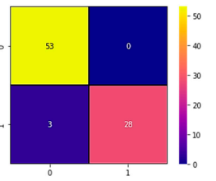

Figure 6. Confusion matrix of the Modified XGBoost.

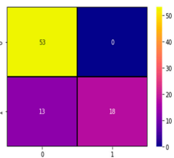

Figure 7. Confusion matrix of DT. Figure 10. Confusion matrix of the Modified XGBoo

Figure 8 Shows The Confusion Matrix Of The NB Classifier, Which Illustrates The Prediction Of Kidney Stones. Using The NB Classifier, The Correct Predictions Are 49—The Absence Of Kidney Stones And 13—The Presence Of Kidney Stones. However, 18 Classifications Are Made Wrongly In That The Absence Of A Kidney Stone Is Predicted Wrongly As The Presence Of A Kidney Stone, And 4 Wrong Classifications Are Made In Which The Presence Of A Kidney Stone Is Predicted Wrongly As An Absence.

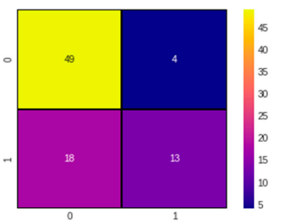

Figure 8: Confusion matrix of NB

4.6. Internal Comparison

The Performance Metrics Of The Modified Xgboost Classifier Attain 97% Of Accuracy, 96% Of F1-Score, 95% Of Recall, And 97% Of Precision. Table 1 Show The 96% Of    F1-Score, 95% Of Recall, And 97% Of Precision.

Table 1. Performance metrics of the Modified XGBoost Classifier

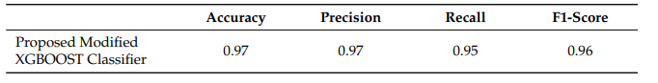

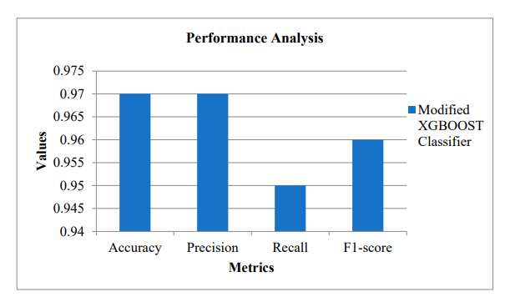

Figure 9. Performance metrics of the Modified XGBoost Classifier

From the extensive analysis, it has been found that, the studies in the field of prediction of kidney stones seems to be lagging, and the dataset used in the present study is a real-time dataset. Hence, it is difficult to perform a comparison with other studies. For that, to assess the efficiency of the present study, the proposed model is compared internally by using the DT and NB classifiers. The performance metrics of the NB classifier attain 74% of accuracy, 68% of    F1- Score, 67% of recall, and 75% of precision. The accuracy of the NB classifier is lower in comparison with the Modified XGBoost classifier. Table 2 and Figure 15 show the performance metrics of the NB classifier.

Table 2. Performance metrics of the NB classifier



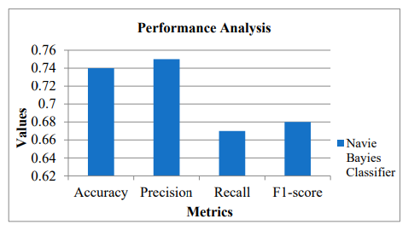

Figure 10. Performance Analysis of the NB classifier.

The performance metrics of the DT classifier attain 75% of accuracy, 69% of F1-Score, 68% of recall, and 77% of precision. The accuracy of the DT classifier is lower in comparison with the Modified XGBoost classifier. Table 3 and Figure 16 show the performance metrics of the DT classifier.

Table 3. Performance metrics of the DT classifier.

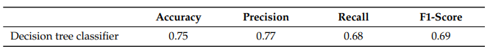

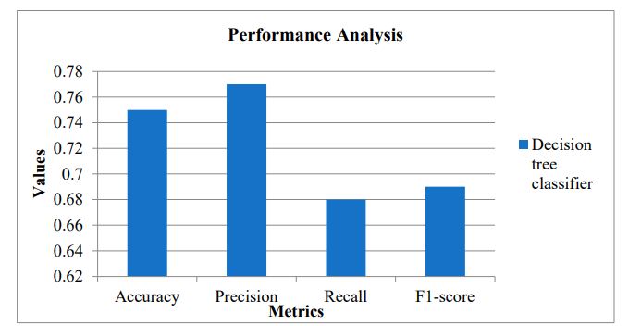

Figure 16. Performance analysis of the DT class

From the internal comparison, it is evident that the proposed method (Modified XGBoost) has attained better values in all the performance metrics, including precision, recall, accuracy, and F1-Score. Table 4 shows the accuracy of the different classifiers with and without feature selection.

# CHAPTER 5

# CONCLUSION

The present study aimed to predict the presence and absence of kidney stones in an IoT-fog environment by designing a smart toilet-based model. Several processes were undertaken to accomplish this. Accordingly, the optimal features were selected by using the Improved MBPSO, and classification was performed by using the Modified XGBoost technique. The dataset used in the proposed algorithm was a real-time dataset. Several features, such as the pH of urine, the osmolality of urine, the conductivity of urine, the specific gravity of urine, the concentration of calcium in urine, and the concentration of urea in urine, were selected by using the proposed MBPSO method. Some features, such as the concentration of calcium and the concentration of urea in urine, were responsible for crystal formation in the kidneys, which leads to the occurrence of kidney stones. The modified XGBoost algorithm was used to perform classification in an IoT-fog environment, and the attained accuracy of the proposed system was 97%. The efficiency of the proposed system was assessed by performing an internal comparison with the DT and NB classifiers, which showed the effectiveness of the proposed model. From the internal comparison, the DT classifier showed an accuracy rate of 0.75, while the NB classifier attainted an accuracy of 0.74. However, the proposed system revealed high accuracy rate of 0.97. Moreover, accuracy rate was assessed for the different classifiers with and without feature selection. The results revealed that the proposed method attained a high accuracy value with feature selection at a rate of 97%, whereas without feature selection, it was 85.269%.

This study possesses advantages with regard to speed and accuracy. However, it also comprises certain pitfalls. The proposed work was specifically outlined to prognosticate kidney stone and might not be applicable for other disease diagnoses. The proposed system demands expertise in XGBoost and PSO. This indicates that it might not be available to non-experts, which might restrict its acceptance in certain settings. Overall, though the proposed algorithm possesses various merits for prognosticating kidney stone, it also possesses certain limitations in terms of restricted applicability and requirement for expertise, which have to be considered for effective usage.

CHAPTER 6

REFERENCES

1. Medina, M.; Castillo-Pino, E. An introduction to the epidemiology and burden of urinary tract infections. *Ther. Adv. Urol.* **2019**, *11*, 1756287219832172. [[**Google Scholar**](https://scholar.google.com/scholar_lookup?title=An+introduction+to+the+epidemiology+and+burden+of+urinary+tract+infections&author=Medina,+M.&author=Castillo-Pino,+E.&publication_year=2019&journal=Ther.+Adv.+Urol.&volume=11&pages=1756287219832172&doi=10.1177/1756287219832172)] [**[CrossRef](https://doi.org/10.1177/1756287219832172" \t "_blank)**][[**Green Version**](https://journals.sagepub.com/doi/pdf/10.1177/1756287219832172)]
2. Day, P.L.; Erdahl, S.; Rokke, D.L.; Wieczorek, M.; Johnson, P.W.; Jannetto, P.J.; Bornhorst, J.A.; Carter, R.E. Artificial Intelligence for Kidney Stone Spectra Analysis: Using Artificial Intelligence Algorithms for Quality Assurance in the Clinical Laboratory. *Mayo Clin. Proc. Digit. Health* **2023**, *1*, 1–12. [[**Google Scholar**](https://scholar.google.com/scholar_lookup?title=Artificial+Intelligence+for+Kidney+Stone+Spectra+Analysis:+Using+Artificial+Intelligence+Algorithms+for+Quality+Assurance+in+the+Clinical+Laboratory&author=Day,+P.L.&author=Erdahl,+S.&author=Rokke,+D.L.&author=Wieczorek,+M.&author=Johnson,+P.W.&author=Jannetto,+P.J.&author=Bornhorst,+J.A.&author=Carter,+R.E.&publication_year=2023&journal=Mayo+Clin.+Proc.+Digit.+Health&volume=1&pages=1%E2%80%9312&doi=10.1016/j.mcpdig.2023.01.001)] [**[CrossRef](https://doi.org/10.1016/j.mcpdig.2023.01.001" \t "_blank)**]
3. Kumar, R.; Jain, V.; Chauhan, N.; Chand, N. An Adaptive Prediction Strategy with Clustering in Wireless Sensor Network. *Int. J. Wirel. Inf. Netw.* **2020**, *27*, 575–587. [[**Google Scholar**](https://scholar.google.com/scholar_lookup?title=An+Adaptive+Prediction+Strategy+with+Clustering+in+Wireless+Sensor+Network&author=Kumar,+R.&author=Jain,+V.&author=Chauhan,+N.&author=Chand,+N.&publication_year=2020&journal=Int.+J.+Wirel.+Inf.+Netw.&volume=27&pages=575%E2%80%93587&doi=10.1007/s10776-020-00496-2)] [**[CrossRef](https://doi.org/10.1007/s10776-020-00496-2" \t "_blank)**]
4. Hamdani, S.W.A.; Khan, A.W.; Iltaf, N.; Bangash, J.I.; Bangash, Y.A.; Khan, A. Dynamic distributed trust management scheme for the Internet of Things. *Turk. J. Electr. Eng. Comput. Sci.* **2021**, *29*, 796–815. [[**Google Scholar**](https://scholar.google.com/scholar_lookup?title=Dynamic+distributed+trust+management+scheme+for+the+Internet+of+Things&author=Hamdani,+S.W.A.&author=Khan,+A.W.&author=Iltaf,+N.&author=Bangash,+J.I.&author=Bangash,+Y.A.&author=Khan,+A.&publication_year=2021&journal=Turk.+J.+Electr.+Eng.+Comput.+Sci.&volume=29&pages=796%E2%80%93815&doi=10.3906/elk-2003-5)] [**[CrossRef](https://doi.org/10.3906/elk-2003-5" \t "_blank)**]